Daniel Khan
for
USI Vice-President for Welfare

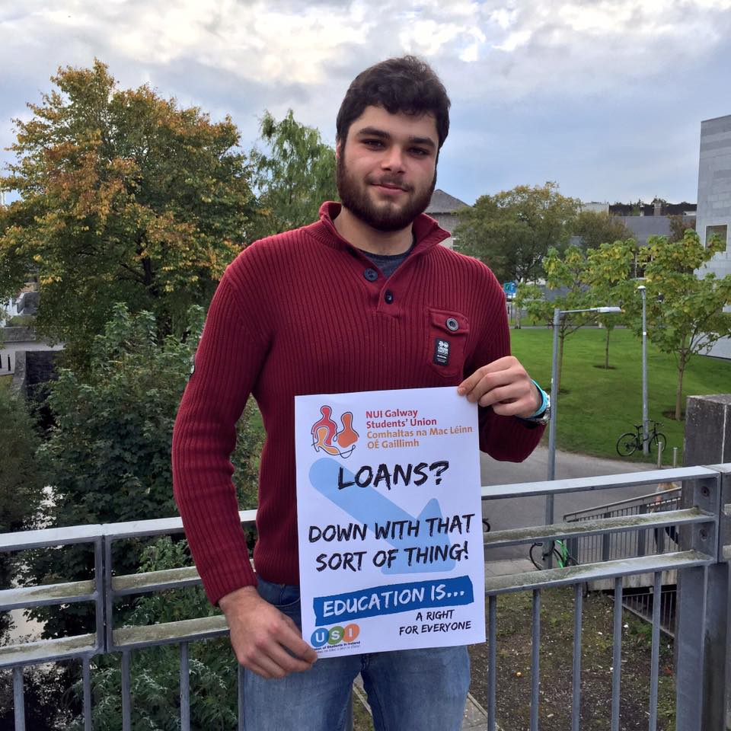
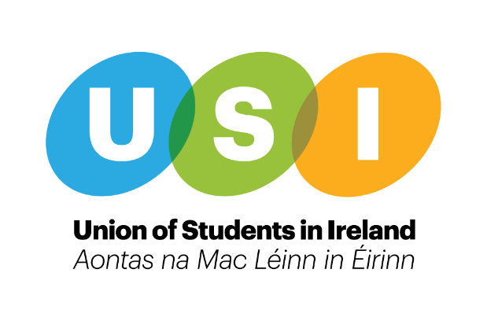
Personal Safety
Hazardous drinking has been identified as the number one substance abuse problem amongst students at third level.

As VP/Welfare I plan to:

- To sustain USI’s role as a key partner in REACT.
- Continue to collaborate with REACT and support Students’ Unions in realising the action points set out in the report.
- To aim, where possible, to establish links with local organisations and resources and promote local supports to students in the campus community.
- To equip officers to support students at risk of developing alcohol dependency.
- Continue to work with national bodies on the issue of sexual assault and drink-related aggression.
- Provide training for relevant officers in SAOR through collaboration with the HSE.

The health and safety of students is a core focus for every Students’ Union.
As VP/Welfare I plan to:
- Continue to work with RSA to help Students’ Unions distribute high-vis vests to students at the start of the year, with a particular focus on cyclists.
- Work with local Students’ Unions in developing a campaign to address the issues surrounding students walking home alone.
Alcohol
The effects of the accommodation crisis are widespread, and unfortunately in times of crisis there will always be people looking to take advantage of people that are desperate to find accommodation.
As VP/Welfare I plan to:
- Lobby relevant bodies to secure funding for the Housing Officer to remain a permanent position within USI for the duration of the accommodation crisis.
- Put together a resource pack for Students’ Unions to promote the importance of having lease agreements through online channels and local media well before their starts of term.
- Work with regional officers to help Students’ Unions host information evening for potential landlords and homeowners. Invite relevant college staff, representative from threshold and a local property management company and local media.
- Lobby relevant bodies to introduce legislation to help protect students in digs style accommodation.

Accommodation
Students have been at the forefront of changing the national attitude towards mental health in Ireland over the last few years.
As VP/Welfare I plan to:
- Work with Regional Officers to help every SU achieve the Amber Flag for suicide awareness.
- Work with VP for Campaigns on creating a national wellness campaign that focuses on managing your mental health day to day, with the ultimate aim of giving students the skills to take control of their own mental health early on before it gets a chance to deteriorate and manifest itself in the forms of anxiety and depression
- Establish, sustain and develop relationships with Mental Health Organisations
- Update the online welfare directory to include a list of mental health services both off and on campus for Students’ Unions, and separate them based on the ages that they cater to, opening hours and price.

Mental Health
The promotion of sexual health information and consent is crucial in helping students taking informed decisions and about sex
As VP/Welfare I plan to:
- Build on work done by a number of Students’ Unions in introducing opt out consent classes as part of students’ introduction to college life.
- Ensure that Students’ Unions are equipped with the information needed to ensure campaigns are gender neutral and LGBTQ inclusive.

When a student reaches out to an officer you can never know what to expect. In a lot of cases a student can be in crisis and disclose sensitive information leaving some officers a little out of their depth.
As VP/Welfare I plan to
- Organise basic training at SUT/SUT+ for all officers that deal with casework, in the areas of:
  - Bereavement
  - Self-Care
  - Effective Listening
  - Disclosure Training
  - Basic Mental Health Referral

Consent
Support for Officers
With the increasing popularity of social media, cyber-bullying has become quite a prevalent issue amongst third level students. Victims of cyber-bullying tend to have lower self-esteem, increased suicide ideation and a variety of emotional responses. Cyber-bullying can be more harmful that traditional bullying in a lot of cases.
As VP/Welfare I plan to:
- Help individual Students’ Unions develop a cyber-bullying policy if not already present.
- Follow on from this by helping Students’ Unions lobby relevant college authorities to introduce disciplinary procedures for dealing with student on student cases of cyber-bullying.

It can take students a while to adjust to the transition from second to third level, with so much going on it can be quite easy to forget to look after yourself day to day.
As VP/Welfare I plan to:
- Develop initiatives and campaigns to encourage students to partake in home-cooking and healthy eating.
- Promote appropriate fitness apps to encourage students to use technology to increase participation in physical exercise.

Cyber-Bullying
General Health
The suicide rate among problem gamblers is 3-4 times higher than that of the general population. There is no current sufficient legislation to combat problem gambling in Ireland.
As VP/Welfare I plan to:
- Seek support from external organisations to strengthen campaigns on the issue.
- Provide a training module for relevant officers during the summer term on the issue of gambling awareness and harm reduction.
- Support Students’ Unions in rolling out training modules for gambling harm reduction for student leaders.

Education at second and third-level is crucial in terms of informing students about drugs and the consequences taking drugs may have on their future
As VP/Welfare I plan to:
- Focus on harm reduction campaigns and initiatives under guidelines set out by the HSE.
- Support unions in establishing local links to support their work in the area of drugs harm reduction.
- Support officers in establishing links with local, community based support services to identify referral paths for students

Gambling
Drugs

Experience:
- Envoy for Dar-ul-Sukoon
- Irish Lung Foundation (Fundraising)
- Aware (Daisy Days Campaign)
- Welfare Crew Volunteer for 3 years
- Involved with the ‘Chats for Change’ initiative
- Involved with the ‘See Change’ initiative
- USI Congress Delegate 2014
- VP/Welfare Officer NUIGSU 2016/2017
- Student Media Rep for Galway Housing Action Group
- Elected member of USI Students for Choice Taskforce

Training:
- SafeTalk Training
- ASIST Training (Applied Suicide Intervention Skills and Training)
- QPR Training
- See Change Training
- Walk in my Shoes Training (St. Patricks Hospital)
- WRAP Training (Wellness Recovery Action Planning)
- Disclosure Training (facilitated by the Rape Crisis Centre)
- Smart Consent (Educating Society on Sexual Consent)
- Pink Training
- SUT/SUT+ 2016
