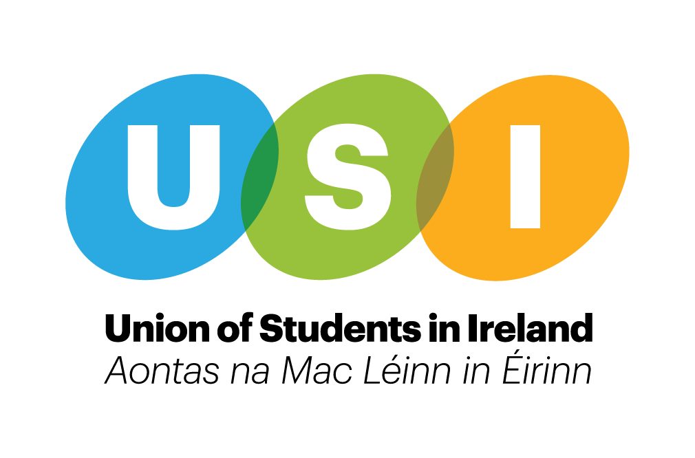

Written submission to the Department of Justice and Equality on the Prohibition of Incitement to Hatred Act 1989

About USI
The Union of Students in Ireland (USI) is the sole representative body for third level students in Ireland and represents 374,000 students in over thirty member colleges across Ireland, North and South. Throughout its history, USI has worked relentlessly in the pursuit of student rights in all areas of the student experience. The goal of USI is to work for the rights of students and a fair and equal third-level education system in Ireland.

USI is a full member of the European Students’ Union (ESU) which represents
students from 46 National Students’ Unions in 39 countries, and a member of INAR (the Irish Network against Racism), ICOS (The Irish Council for International Students) and have been involved in the drafting and implementation of the LGBTI+ Youth Strategy. .

Introduction
USI welcome the opportunity to put forward a submission towards the public consultation on the Incitement of hatred Act 1989. In a rapidly changing Ireland that is constantly widening in diversity, hate speech and hate crime as a consequence, are becoming an increasing issue. USI feels largely these issues are down to the provision of education and information, but also that we need a robust system of legislation in place to tackle such issues and ensure that all citizens feel safe and respected in modern Ireland. Third level institutions can quite frequently be seen as pioneers of Equality, Diversity and Inclusion agendas, but we believe there is more to be done within the Education system and with society as a whole. .

Issue 1: list of protected characteristics:

USI believes that hate speech can be targeted towards many different minority groups and that the act needs to be expanded to include the following characteristics:

-Disability
-Gender
-Family status
-Trans, non binary and intersex individuals
-Minority Language and or languages associated with different nationalities, religions or ethnicities etc.
-The refugee status of a person

USI recognises an intersectional approach to identity and hopes the act would reflect this. Often hate speech can be targeted towards someone due to multiple parts of their identity, as opposed to just one characteristic.

Issue 2: use of the term hatred in the act

USI believes that hate is too high a threshold and the lack of prosecutions under the act is a testament to this. The rigid nature of this restricts minority groups in feeling empowered to report incidents of hate speech against them. We would suggest that whatever word is to be used in this legislation is adequately defined to reflect what the legislation is trying to tackle.

Issue 3: Online Communications

It is USI’s view that the act should be amended to include specific reference to social media. Hate speech takes a home online, as people are able to hide behind the anonymity of the keyboard.

The last number of years have seen the numbers of those using social media rise and rise, students in particular are very present on social media, and as such at risk of hate speech. Both the USI Mental Health report and the Jigsaw My World 2 survey reported 99% of respondents have social media accounts online. Furthermore, the My World Survey 2 stated that a signiﬁcant relationship between time spent online (more than three hours) and higher levels of depression and anxiety and lower levels of body esteem.

From the My World 2 survey conducted by Jigsaw and UCD School of Psychology; of the young adults surveyed, 58% said their status was private on the social media site they used most often so only their friends could see the content, while 23% said it was partially private (i.e., friends of friends can see) and 17% indicated it was public (i.e., everyone can see). Therefore it’s clear that social media is not ‘private’ even if people consider it to be.

We also echo ICOS’s calls to Engage with social media providers, and other stakeholders, to ensure that they are accountable for policing their sites and their users’ content

See also USI’s submission on Online harassment for more information in this area

Issue 4:
At the moment, the justice system doesn’t support victims of hate speech as it is difficult to prove intent. We are not legislative experts but echo calls to expand the legislation so that intent does not have to be proven in order to prosecute. This can frequently mean that the burden falls on minority groups to prove the hatred was intended against them.

As the Call it out campaign highlights, words that people may throw around, thinking they are harmless and funny can be very hurtful to members of the LGBT+ community (and by extension other minority groups) because those jokes and words have been used as weapons against them. Hate speech doesn’t only affect the person it’s aimed it, but it affects the whole community as it helps to foster a sense of fear in minority communities. We would support looking at a holistic view of crimes of hate speech looking at the aftermath, mentioned above, this legislation has a great opportunity to instil confidence in state agencies that minority groups are protected and encouraged to be their whole selves.

Other issues to take into consideration:

We cannot take hate speech legislation in isolation and would be remiss of us to not use this opportunity to open up a dialogue about the causes of hate speech and how these could be tackled at a national level. While there are already some strategies and programmes in place to mitigate sexism, racism, homophobia etc. USI believes that there are measures that could be taken at a national level that would generally combat the kind of rhetoric that leads to hate speech against a particular group. These measures would include:

- The rolling out of unconscious bias training, both at higher education and a national level and provision of no hate speech ambassadors at third level.

- LGBT+ and intercultural training in schools. This has also been a recommendations to the review of the Relationships Sexuality Education in secondary schools (RSE)

- For people with religious beliefs: improved facilities, catering services and supports across a range of faiths.
- That each third level institution would have policy to address issues of hate speech, whether it be through disciplinary action or otherwise. There should be a dedicated section to online hate speech in this policy.

- The Implementation of IHREC recommendations from CERD report.

- Adequate training for the Gardaí for any legislation introduced.

Hate Crime legislation:

USI would also like to take this opportunity to advocate for the introduction of Hate crime legislation. The Gardaí have taken steps to address this issue in Irish society, but until we have the legislation in place we cannot truly take stock of incidents that happen and prosecute accordingly.

Summary of recommendations:

- ‘Hate’ is too high a threshold and too rigid, it should be replaced with another term that’s more flexible and broad

- The act needs to be expanded to include the following characteristics: Disability, Gender, Family status, Trans, non binary and intersex individuals, Minority Language and or languages associated with different nationalities, religions or ethnicities etc., The refugee status of a person.

- The act should be amended to include specific reference to social media.

- The rolling out of unconscious bias training, both at higher education and a national level and provision of no hate speech ambassadors at third level.

- LGBT+ and intercultural training in schools. This has also been a recommendations to the review of the Relationships Sexuality Education in secondary schools (RSE)

- For students with religious beliefs; improved facilities, catering services and supports.

- That each third level institution would have policy to address issues of hate speech, whether it be through disciplinary action or otherwise. There should be a dedicated section to online hate speech in this policy.

- The Implementation of IHREC recommendations from CERD report

Closing remarks

USI would like to thank the committee for the opportunity to submit a written recommendations on this important issue that affects many of our student members.

If you have any questions about this submission you can contact the Vice President for Equality and Citizenship, Megan Reilly (equality@usi.ie / - 0864149758 ) or Roisin O’Donovan, Vice President for Welfare(welfare@usi.ie / 087 2809 703)

