Jimmy McGovern  
Vice President for the  
Border, Midlands & Western Region

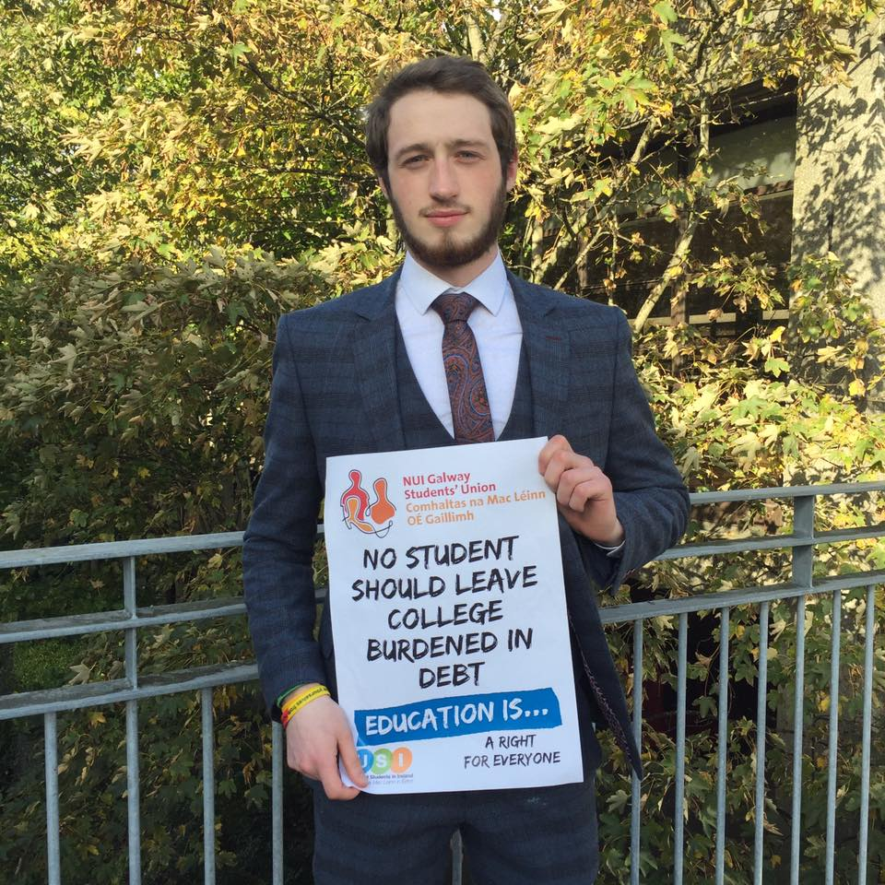

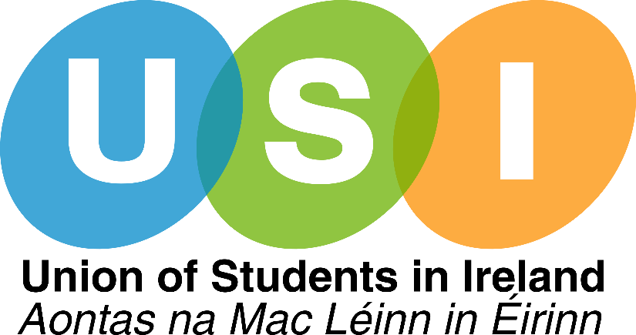

**Affiliation Referendums**Work with and support Students’ Unions willing to reform their constitutions regarding automatic   
USI affiliation referendums. This will be a fundamental priority for the year.

**Further Education Colleges**Liaise with Further Education Colleges to join the national movement, growing USI to its full potential.

**External Representation**Seek to secure student representation on external bodies, services and committees that are relevant to the student experience.

**Second Level Students’ Union**Work with Second Level Students’ Union Officers to run awareness campaigns of third level Students’ Unions, with the aim to grow future engagement.

**Elections**Assist Students’ Union Officers in promoting their local elections and ensure every officer within the region has the opportunity to get advice, guidance and encouragement to run for election at a national level. I will personally advocate this.

**Future Growth of USI**

**National Campaign**Lead the BMW Region’s involvement in the national campaign for publicly funded education and opposition of a loan scheme. Work closely to educate each SU to ensure full understanding.

**Local Campus Campaigns**Be present for local campaigns such as Mental Health and SHAG Week and assist in promoting them by giving on campus lecture addresses.

**Media**Joint USI and local Students’ Union press releases to local media. These will be regular to increase Students’ Unions’ community engagement and also awareness of USI partnership.

**TD Engagement**Attend TD meetings with local Students’ Unions  
to ensure continuity in the national message   
on higher education funding**.**

**Vice President for Campaigns**Local to National and National to Local Liaison.  
Be the communication that local Students’ Unions need to best achieve both their goals, and the goals of the Vice President for Campaigns.

**Campaigns**

**Personal Support for Officers**Provide support, guidance and advice to officers for all aspects of their roles. Such as effective representation on committees, local campaigns, teamwork, leadership, casework, self-care, etc.  
**Full-time & Part-time Officer Training**Organise regional Part-time Officer training with learning outcomes set by local Students’ Unions, and also ensure every Sabbatical Officer has undergone a form of ‘Students in Distress’ training.  
**Team Building**Organise team building for every full time officer within the region to form the best possible working relationships. Attend local team building to grow working relationships with Part-time Officers.  
**USI & Local SU Engagement**Engagement with Class Reps through regular SU Council attendance. Use this as a forum to both inform SU Councils of USI’s activity and also to bring your issues to the USI Officer Board, and ensure those needs are met as means for your Students’ Union to grow and develop.   
**Regional SU Officers Council**Organise and chair a Regional Council with all Full-time and Part-time Officers once a semester.

**Union Development**

**Voter Registration**Register a fixed percentage of students to vote on every campus within the region. Campaign all year round until target is achieved.

**Women in Leadership**Advocate the Women in Leadership programme and ensure members from every Students’ Union within the BMW Region attend. Grow this program to the largest it has ever been.

**Activist Academy**Work with Officer Board to organise an Activist Academy, ensuring every student has the access to the inspiration, training and network, to advocate for the causes they believe in.

**Vice President for Equality & Citizenship**Local to National and National to Local Liaison.  
Be the communication that local Students’ Unions need to best achieve both their goals, and the goals of the Vice President for Equality & Citizenship.

**Equality & Citizenship**

**National Student Engagement Program**NUI Galway was a pilot for the National Student Engagement Programme (NStEP) and I will use my experience to aid local Students’ Unions in the development and implementation of the NStEP.

**Academic Support**Use case studies from NUI Galway to help other Students’ Unions to draft proposals for additional academic supports (i.e. Writing Centre, Mathematics Tutoring, Peer to Peer initiatives, etc.)

**Representation**Work closely with Presidents and Education Officers to secure student representation on academic boards and committees, using comparatives across the region to make the case.

**Vice President for Academic Affairs**Local to National and National to Local Liaison.  
Be the communication that local Students’ Unions need to best achieve both their goals, and the goals of the Vice President for Academic Affairs.

**Academic Affairs**

**Alcohol & Drugs**   
Work with the Regional Drug & Alcohol Task Forces towards a harm reduction approach to drug and alcohol use, and secure Student Representation on each Regional Steering Committee.

**Support Services**  
Work with the Regional Children & Young People's Services Committees to improve access and awareness for students and local support services. Work to secure Student Representation on each Regional Committee.

**Accommodation**  
Work with local Students’ Unions to host regional events for questions & answers sessions for homeowners considering renting to students, as an aim to secure additional student housing.

**Vice President for Welfare**Local to National and National to Local Liaison.  
Be the communication that local Students’ Unions need to best achieve both their goals, and the goals of the Vice President for Welfare.

**Welfare**

**Oifigeach na Gaeilge**Run in conjunction with local SU’s a referendum to ensure there is a Part-time Oifigeach na Gaeilge in every Students’ Union within the Region.

**Irish Language Working Group**Establish and co-facilitate with the Leas Uachtarán don Gaeilge a regional working group for Irish Language Officers to plan national campaigns.

**Gaeltacht Scholarships**Lobby for additional scholarships for summer Gaeltachts for second level students, aimed to increase both interest and ability to speak as Gaeilge on a casual basis.

**Leas Uachtarán don Gaeilge**Local to National and National to Local Liaison.  
Be the communication that local Students’ Unions need to best achieve both their goals, and the goals of the Leas Uachtarán don Gaeilge.

**Gaeilge**

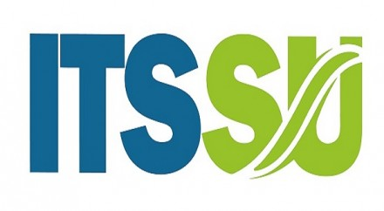

4 Certificates in Suicide Awareness, Detection & Intervention

**3 Certificates in Mental Health Training**

Bystander Intervention

**Drug & Alcohol Intervention**

Occupational First Aid

**Child Protection Training**

Anti-Racism Training

**USI Pink Training (LGBT+ Support)**

SMART Consent (Educating Society on Sexual Consent)

**Disclosure Training (by Galway Rape Crisis Centre)**

USI Activist Academy

**Communication & Media Training**

Effective Problem Solving and Decision Making

**Student Governor Development Training (Leadership Foundation)**

**Jimmy’s Training**

**President, NUI Galway Students’ Union**

Member of Governing Body, NUI Galway

**Director, Students’ Union Commercial Services Ltd.**

Vice President / Welfare Officer, NUI Galway Students’ Union (2015/16)

**Two-time Overseas Volunteer in Zambia, Africa**

Steering Committee, Western Region Drug & Alcohol Task Force (Galway/Roscommon/Mayo)

**Committee Member, Children & Young People’s Services (Galway/Roscommon)**

Member of Academic Council, NUI Galway (2 Years)

**SU Elections Committee**

Final Year Class Rep (220 Students)

**USI Congress Delegate (2014, 2015 & 2016)**

Welfare, Equality & Educational Rights Volunteer (2 Active Years)

**Numerous Fundraising Projects**

**Jimmy’s Experience**