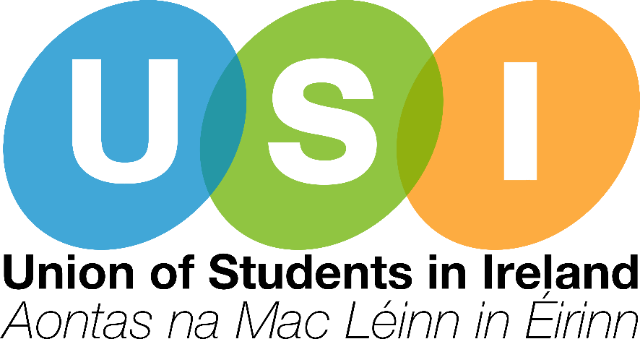

Leaving Certificate Reform
USI Submission
October 2021

Introduction
The Union of Students in Ireland (Aontas na Mac Léinn in Éirinn) is the national representative body for third-level Students’ Unions in Ireland. Founded in 1959, USI now represents more than 374,000 students in over thirty colleges across the island of Ireland. The goal of USI is to work for the rights of students and for a fair and equal third-level education system in Ireland.
USI is a full member of the European Students’ Union (ESU) which represents students from 46 National Students’ Unions in 39 countries.
It must be noted that USI’s core mission has always been to protect access to education, ensure equal opportunities for all and remove any barriers that prevent the pursuing of a third level degree.
USI believes that the Leaving Cert, in its current structure has prevented too many students from entering their preferred third-level course, due to the unjust points system which acts as an entry exam into college.
- Assessment Options
1.1 The current assessment practices for the Leaving Certificate are very restrictive and do not allow students to excel and meaningfully demonstrate their knowledge on a particular topic. The Leaving Cert is often based on a single written exam which tests the student’s memory and ability to retain information on one day, resulting in enormous pressure and stress placed on a student to perform. Many students fall ill, have personal circumstances arise, have family bereavements or bad days recalling course material. The Leaving Cert, which can be seen as an entrance exam to Higher Education in this State, does not take this human factor into consideration.
1.2 To permit all students to succeed in showcasing their strengths in a subject, they must be supported to illustrate their knowledge through a mechanism that enhances their learning, rather than attempting to confirm one's ability to reiterate material learnt off by heart. A survey conducted by the Irish Secondary Schools Union (ISSU) in conjunction with ESRI worryingly found that 57.4% of students believe that the Senior Cycle does not encourage creativity, curiosity and engagement (Senior Cycle Reform, 2020). This is highly concerning due to the importance of such skills being considered as “top competencies” by the World Economic Forum (The Future of Jobs, 2020).
1.3 Future assessment practices must be more flexible, supportive and capable of accommodating the diverse needs of the student. This must include a mix of formative and summative assessments to ensure that no student is left behind. This can be achieved with more continuous assessment, multiple-choice questions, practical and oral work and important experience in practices such as group work, presentations and class discussions. Students should also be consulted on the methods of assessment that suit them to ensure an ever-evolving, best-practice approach is taken.
1.4 An essential part of the discussion is around the multiplicity of methods of teaching in the modern classroom. The teaching and learning environment must adopt a ‘universal design for learning’ approach to ensure every student can fully participate in their education (AHEAD, UDL Framework, 2017). In the last two years, the Leaving Certificate has not been completed in the traditional format due to COVID-19, and it is USI’s opinion that this should not be the form reverted back to. We believe that the Department has a huge opportunity to ensure these assessment practices, which have been in place for over a hundred years are reformed and renewed to be in line with best practice guidelines. We have the chance to do right by the thousands of students across the country for whom these examinations determine the trajectory of their lives.
- Key Subject Areas and Digital Learning
2.1 COVID-19, although having a significant negative impact on students, certainly brought many advantages to the field of digital learning due to the rapid nature in which we turned to the online space. This shift, in many cases, lead to education becoming more accessible and accommodating for the students who needed it. The investment and exploration to digital learning practices is recognised as an evolving and ever-growing area, but we must bridge the digital divide to ensure all students have equal opportunities. It must be noted that not every student has a laptop, sufficient internet connection or the technology and software needed to engage in an online hybrid model. We need state funding to support students and expand the national broadband plan to ensure that no one is put at a disadvantage.
2.2 A recent IBEC survey found that four in five Irish CEO’s consider preparedness for technological change as a crucial skill. (IBEC Digitalised Europe Prioroties, 2020) Students must be able to build their digital skills and capacity in order to enter today’s workforce. The Irish education system has played a vital role in societal and economical evolution in the last few decades. As we recover from the impacts of the COVID-19 pandemic, we have a real opportunity to improve the digitalisation of our education sector, but this can only be achieved through innovative and sustained investment to meet the demands of the workforce, industry and society. USI urges the Department to establish a cross-governmental national digital strategy to continue work in this space. This would ensure the flexibility of methods to complete examinations and would see the inclusion of digital literacy skills within the Leaving Certificate curriculum.
2.3 USI concurs with ISSU’s call for the improvement of the provision of Relationship and Sexuality Education (RSE) following the findings of the forementioned survey which found one in three students did not receive any form of RSE and of those who did, 60.4% were provided with a very minimal level (Senior Cycle Reform, 2020). USI echoes ISSU’s calls for legislation to ensure that RSE classes are provided in a secular, denominal format not influenced by the characteristics of any school and for the material to be approved by a relevant union within the Health Service Executive.

- Access & Equality
3.1 Far too many students and parents encounter serious financial difficulties due to the strain of costs associated with education. This includes uniforms and books which should be freely available for all students in order to engage in their studies while in second-level education. The inaccessibility of the Leaving Certificate is a long-standing issue. The expansion of access and progression routes are welcome, yet they still remain inaccessible to many students. HEAR and DARE applicants are required to go through a labour-intensive process which often requires a large amount of paperwork and proof of diagnosis which come at an additional cost, hindering the accessibility of such schemes.
3.2 There is an urgent need for investment in second-level schools around the country to facilitate the expansion of the subjects currently offered, and to alleviate the disadvantage of students particularly in DEIS schools. Outreach initiatives and programmes should be developed to encourage students from more disadvantaged backgrounds to continue on their educational journey. In addition, USI believes that we must do better to support students who are living in Direct Provision and are members of the Irish Travelling Community.
3.3 Ireland’s Higher Education Fees being the highest in the European Union is the most serious and unavoidable barrier to pursuing a third level degree. We urgently need publicly funded education to ensure the generations to follow are not faced with the same challenges today’s school leavers experience. Too many students much choose between entering the workforce full time or struggle to make ends meet while attending higher education.
- Wellbeing Supports
4.1 The mental health and wellbeing of students must always inform the reformation of the Leaving Certificate. The examinations place undue stress and pressure on students and has a significant impact on their mental health. There must be a greater awareness of these impacts and educational programmes should be rolled out to improve the knowledge of supports for a student’s health and wellbeing. Guidance counsellors should primarily look out for students’ wellbeing while attending school. In addition, teachers must be equipped with minimum training standards in the areas of student mental health in order to be able to recognise, intervene and signpost appropriately when a student is in distress.
- Higher and Further Education Requirements, Vocational Options and Career Paths
5.1 USI believes that every person regardless of their age, personal circumstances, financial background and journey should be able to attain the level of education they desire. Alternative education pathways following the leaving certificate need to be supported and developed. Not every student wants to go to college. A PLC course, apprenticeship, entry into the work force and taking a year out for self-development can each be as valuable. However, the current use of the Leaving Certificate as a college entrance exam devalues and undermines these options. These alternative options to third level education are often deprecated and seen as a lesser back-up plans for students who ‘fail’ to earn the points necessary to secure a place on their chosen course. Each person has different interests, skills and ambitions in their life, a hierarchy of approved pathways through lifelong learning is not of benefit to anyone.
5.2 Career & Guidance Counsellors should support students through the decision-making processes they face and the transitional period to their young adult lives. Matriculation options for students applying to higher education must be expanded and incentivised for Higher Education Institutions. Many students are disadvantaged due to the nature of the Leaving Certificate examinations and should have further alternative options in applying to third level similarly to many of our European counterparts.
5.3 While the conversation surrounding further education is improving and much welcomed, there is further work to be done to ensure that students pursuing a level 5 qualification following the completion of their Leaving Certificate are valued, empowered and supported. USI recommends Irish Secondary Schools collaborate with local Education and Training Boards to share their resources and ensure the provision of further subject areas to be made available to students who are completing their senior cycle.
5.4 The timing of the Leaving Certificate results is a long-recognised barrier to students being able to attend further and higher education. The long summer wait, and short turnaround time significantly disadvantages students who wish to apply for the UK and other international options.

- The Irish Language and Irish Medium Education
6.1 USI’s paper on the Teaching of Irish published the results of a survey conducted in 2018/19, found that most respondents were sympathetic to the language with 67% of respondents believing that the Irish language should remain as a compulsory subject at Leaving Certificate level (USI, Teaching of Irish Report, 2021).
6.2 Additionally, through consultation with our members, working groups and external organisations, largely Conradh na Gaeilge, USI has been calling on the government to close consultations that are currently open looking at the teaching and assessment of Irish, and encourage the launch of a consultation into a comprehensive policy on Irish in the education system from pre-school to tertiary education.
6.3 We believe it to be unfair to ask pupils from Gaeltacht areas, Gaelcholáistí and those of a higher level of Irish to sit harder exams, without any additional points awarded for doing so. This is a recommendation being considered by the National Council for Curriculum and Assessment. However, this is creating concern and anxiety for many students.

- International Evidence and Best Practice
7.1 As it currently stands, Ireland’s focus on summative assessment at the end of a two-year senior cycle course leaves students at a disadvantage causing stress, worry and unnecessary amounts of pressure to perform to the best of their ability on the day. The Leaving Certificate does not consider skills and talents. The United Kingdom facilitates interview stages which explore a student’s engagement in work experience, extra curriculars and other skills. This process incentivises students to engage in meaningful and important activities which assist them in understanding the work they enjoy, and gain invaluable experience in real-life settings.
7.2 The International Baccalaureate programme provides students with the opportunity to engage in various types of oral assessments in languages, fieldwork for sciences, performance in creative arts as well as external assessments. These practices should be employed in the Irish setting and would empower students to be ‘future ready’. Unfortunately, while Ireland is recognised as ‘the land of saints and scholars’ and in recent years has become home to some of the world's leading companies, we do not have a fair and equitable landscape when it comes to education. Access, progression and quality of learning urgently need to be improved and steps must be taken to ensure equal opportunities for all.
7.3 As part of the European Higher Education Area, Ireland must push forward on our work on the Bologna Process, allowing our students to engage in ‘learning mobility, cross-border academic cooperation and the mutual recognition of study periods and qualifications earned abroad.’ The Bologna reform is imperative to ensuring we maintain a dialogue with our 48 European counterparts regarding the reform of our education system and share questions in relation to determining principles of our sector.
Conclusion
In conclusion, USI welcomes the public consultation on the Leaving Certificate Reform and the opportunity to provide a written submission. We are now faced with an unmatched opportunity to reform a system that has been left ignored for decades. Students and our higher education sector urgently need commitment to this reform.
The education provided to our students must be accessible, accommodating and flexible to meet the learner where they are at in their educational journey. The Leaving Certificate as it is now, is failing our students by being too restrictive, not being reflective of a student’s true ability and by causing undue amounts of stress and pressure. We have a significant life-changing opportunity at our hands, which could, and must, change the future of our education system for the better for years to come.

