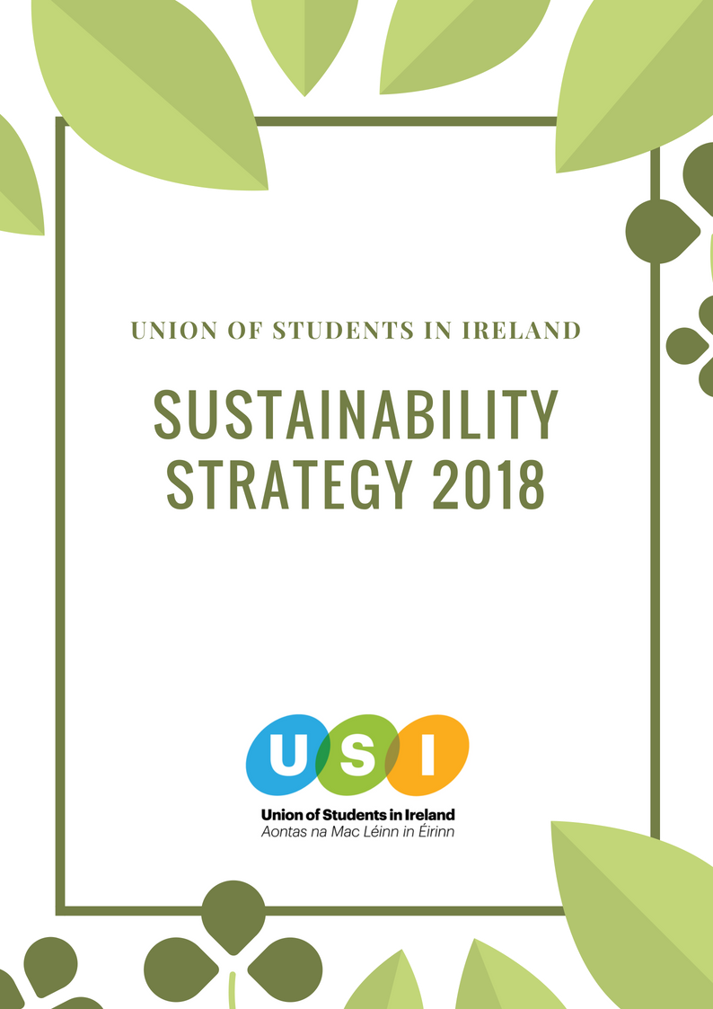

# FOREWORD

The Union of Students in Ireland (USI) is committed to improving educational experiences, campaigning on social issues and making a positive impact for students and wider society. We want to continue this positive impact on the world by outlining our aims for a more environmentally sustainable organisation and we want to ensure USI continues to have a positive impact for years to come.

Our aim in outlining our commitments is for our members to also become more aware of their work in this area and continue to enact policies and procedures that benefit their organisations. We want all of our members to become more aware of the changes they can make and we aim to equip them with the tools and knowledge necessary to reduce their environmental impact on the world.

USI sought to support our work in this area by applying to be involved with the SAVES2 project, focussing on energy usage in student accomodation. Successfully being part of this project has been a catalyst for this strategy to be put in place.

One of the commitments USI made in its formation in the 1970’s was to the environment, with Environmental Officers being a part of the officerboard from the early beginnings. We want to continue our objectives in this area in the form of this strategy and work towards a better USI as a whole.

Thank you,



**Michelle Byrne**

*Vice President for the Southern Region with*

*Responsibility for Environmental Policy.*

**2017/2018**

## 

## Table of contents

**FOREWORD** **1**

Table of contents 2

Mission 3

Vision 3

Strategic Goal 3

**PEST analysis** **4**

1. Political 4

2. Economic 4

3. Social 4

4. Technological 5

**Key areas for implementation** **5**

1.Education 5

2. Waste Management 6

3. Energy 7

4. Partnerships and Stakeholders 8

Review of the Environmental Sustainability Strategy 9

*Sustainable development is “development which meet the needs of the present without compromising the ability of future generations to meet their own needs” - Brundtland G et al (1987)*

*When USI refers to sustainability in this and future documents we are incorporating the three pillars of sustainability: Environmental, Social and Economic.*

## 

## Mission

To minimise the environmental impact of USI and its Member Organisations and engage the student body , staff and wider community in become active citizens for sustainability.

## 

## Vision

The USI Environmental Strategy lays out a roadmap for the promotion of sustainability and environmental action for the whole organisation

Over the next three years .The strategy is neither exhaustive nor limiting, and is subject to evolution; additional responsibilities will be added to the VP Equality and Citizenship brief among others through the democratic procedures of the organisation.

## Strategic Goal

To increase the sustainability of USI and its members through the embedding of sustainable objectives and targets into all aspects of our work, including but not limited to, business practises, operations, education, campaigning and interactions with partners.

# 

# PEST analysis

### 1. Political

The global community has made great strides in trying to address sustainable development in recent decades with the implementation of ‘Millennium Goal and the Sustainable Development Goals’. We have seen the introduction of new laws, policies , directives and initiatives by national and international governments and institutions in an effort to reach the targets we have set out and tackle climate change. Furthermore in the last twelve months both the Irish Government and European Union has proposed legislation like:the Waste Reduction bill in Ireland and the European Commission directive in single use plastic, tackling some of the key environmental problems we are facing.There is still a long way to go but it makes it the perfect time for USI to enter into the sustainable field.

2019 will see both EU and local elections take place which provides a key opportunity for USI to lobby politicians and parties to adopt more sustainable policies

### 2. Economic

The adoption of new sustainable policies and procedures can initially cost the organization more money, but in the long term should lead to a reduction in expenditure. It will also open new avenues to funding supported by the Government, institutions and NGOs.

There is a growing interest in the private sector to carry out more sustainable practices which opens up more companies to USI to partner with and provide sponsorship towards our sustainable campaigns. This can be accessed through Corporate Social Responsibility (CSR) practices from larger EU-based corporates based in Dublin.

### 3. Social

There is a growing sustainable movement amongst the student body and a rise in the number of environmental societies on campus.Additionally, there are 27 campuses formally registered with An Taisce Green Campus programme.

Young people continue to be at the forefront of the environmental movement. Students have led successful environmental campaigns which have led to positive changes on campuses and transformed their institutions policies such as Fossil Free TCD, plastic free campaign in DCU. In this regard USI will be being a joining an already productive movement.

USI has a long and proud history of campaigning on environmental issues since the 1970s. However, USI is now starting to become champions in the field after some years of being absent or on the sidelines on the issue.

### 

### 

### 4. Technological

Technological advances,such as digital communications, have made it easier for organizations such as USI to adopt sustainable policies and procedures. It also ensures we can reach our members through zero waste methods.

Technology has also been leading the way in solutions for many unsustainable practices , energy, transport etc . On the contrary the development of certain technologies has lead us to the unsustainable lifestyle and practices the world is currently leading.It is important that USI strikes the right balance when it comes to using technology.

# 

# Key areas for implementation

1. Education
2. Waste Management
3. Energy
4. Partnerships

### 1. Education

Fostering behavioural change towards reducing our impact on the environment requires all stakeholders being aware of their own impact and how they can improve it.

|  |  |  |  |
| --- | --- | --- | --- |
| **Objective** | **Key Personnel** | **Actions** | **Indicators** |
| Engage and inform USI Staff & Officers on USI sustainable policies and procedures. | Sustainability Manager  VP for Equality and Citizenship  General Manager | Each new member of staff and officer board to undergo a sustainability training as part of their introduction. | Each USI officer and staff member completes training.  USI Staff & Officers implement sustainable policies and procedures undertaking their own work. |

### 

### 

|  |  |  |  |
| --- | --- | --- | --- |
| Inform and raise awareness to all members/partners of sustainability issues and the relationship to their own activities. | Sustainability manager  VP for Equality and Citizenship  VP for Campaigns  All Officer Board  Students’ Unions  Future Partners | Create a ‘sustainability guide’ which outlines the key areas and actions in which the Students’ Union can implement to reduce their environmental impact. It would cover areas such as sustainable campaigning, waste management, energy reduction etc  USI to run two sustainability  campaigns a year  USI to create an online platform for resources and policies pertaining to USI commitment to environmental sustainability. | 30% of the USI members would adopt sustainable campaigning measures  Two sustainability  campaigns are ran  Content added to the USI website on environmental sustainability. |

### 

### 2. Waste Management

Promoting waste minimisation and reducing the environmental impact of waste to landfill through beneficial reuse and recycling activities.

|  |  |  |  |
| --- | --- | --- | --- |
| **Objective** | **Key Personnel** | **Actions** | **Indicators** |
| Minimise the environmental impacts of our campaigns | All staff and OB | Sustainability audit is carried out of the beginning of each campaign.  Procedure is put in place where members request the amount of material they need  (subject to funding conditions)  A waste disposal policy is created for materials and campaign related activities. | Environmental  methods are used during campaign  (materials, information distribution etc )  Produce less physical material  Increase in recycling & reusing & donations. |

|  |  |  |  |
| --- | --- | --- | --- |
| Adopt sustainable measures when organising events | All staff and OB | A guide to how make events more sustainable is created and adopted  USI events exclusively use products recognised as ‘Fairtrade’ where practicable  Carry out an sustainable audit before and after each event. | We reduce our environmental impact of events by 70 % |
| Implement procedures which prevents waste in the day to day operations of USI | Sustainability manager  General Manager  Administrator | Information around office on waste management  Introduction of compost bin  Computers are set to print double sided | Increase in our recycling and composting |

### 

### 3. Energy

Promoting energy efficiency and responsible energy management and use.

|  |  |  |  |
| --- | --- | --- | --- |
| **Objective** | **Key Personnel** | **Actions** | **Indicators** |
| Advocate to members and students to adopt energy saving habits | Sustainability manager | Run Student Switch Off campaign | Targets outlined in project are met |
| To prioritise the use of low carbon energy sources and effectively utilise efficient products and services | General Manager  Administrator  Sustainability Manager | Buy high energy rating appliances  Use energy saving light bulbs/natural sunlight when possible  Carry out an audit of energy usage on office | Reduce our consumption of energy by 15% each year  Switch light bulbs  Implement the recommendations |

|  |  |  |  |
| --- | --- | --- | --- |
|  |  | In new permanent accommodation, investigate the possibility of sunlight routing for offices without natural light  In new permanent accommodation, give high priority to energy suppliers able to guarantee low carbon source energy |  |

### 

### 4. Partnerships and Stakeholders

Gathering the expertise of partner organisations in sustainability, consciously seeking to work with organisations capable and willing to further mutual work in the area.

|  |  |  |  |
| --- | --- | --- | --- |
| **Objective** | **Key Personnel** | **Actions** | **Indicators** |
| Develop partnerships with key stakeholders in the sustainability field | Sustainability manager  VP for Equality & Citizenship | Conduct a mapping exercising & analysis to identify possible partnerships both external and internal in institutions  Meet with identified stakeholders  Support Students’ Unions in creating Sustainability/  Environmental Officers or ambassador roles locally. | Partnerships are in place  Establish a point of contact within partner organisations  Increase engagement with environmental societies & Green campus.  Sustainability/  Environmental officers/ambassador roles created. |

|  |  |  |  |
| --- | --- | --- | --- |
| Secure agreements with all partners that the projects/event are achieved through most sustainable methods possible | All OB and staff | Make partners aware of USI sustainable policies and procedures | Events and campaigns are more environmentally friendly |
| Ensure USI has relationships with experts for the navigation of this strategy. | VP for Equality & Citizenship | The inclusion of experts in the area of sustainability are included on VP Equality & Citizenship Advisory Panel. | VP Equality & Citizenship Advisory Panel contains experts in this area. |

## Review of the Environmental Sustainability Strategy

There should be an annual review of the strategy, to be presented no later than the second National Council for the year. This review should assess progress of the strategy, along with taking into account the experience of local SU officers. The review should also consider how action points can be refined or developed further, particularly in view of new or enhanced data that may become available over the course of the strategy.

## Acknowledgements

Thank you to Darcy Lonergan, the USI SAVES2 Energy & Sustainability Coordinator, who had a large amount of input into this strategy.

