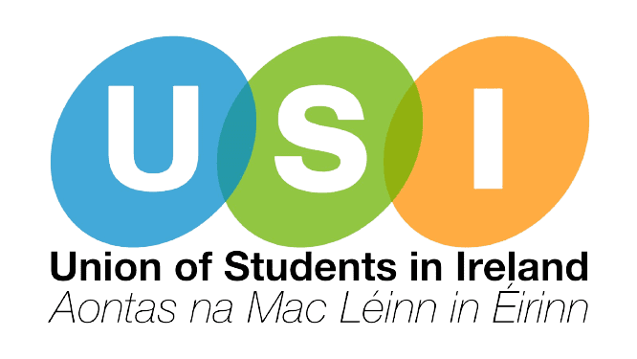

Zoom Link: <https://us02web.zoom.us/j/82927972182?pwd=83sX8FXhGbyuDS7Ur1CgC0tEN3CSZS.1>

**Comhairle Náisiúnta AMLÉ**

National Council of the Union of Students in Ireland, October 2024

**Meeting/Cruinniú:** National Council / Comhairle Náisiúnta

**Date & Time/Dáta & Am:** October 24th/24ú Deireadh Fómhair, 4:30pm

**Location/Áit:** Coláiste na Tríonóide/ar líne

**Atteendees:** Jenny Maguire TCDSU-AMLCT, Shauna Ó Toole TUDSU, Amelia Lown TUSSU, Nathan Murphy USI/AMLÉ, Ryan Harte ATUGM, Tobi Bewaji DKITSU, Faye Ní Dhomhnaill CMLOG, Kyla Henry MSU/AMLMN, Jordan Buckley NCISU, Olivia Harrington NCADSU, Simone James IADTSU/AMLIEDT, AJ Shipley TUSSU, Kevin Sweeney ATUDSU, Richard Noonan MTUCSU, Katie Halpin-Hill UCCSU, Roddie Mac Aonghusa MSU, Mark Dunne SETU, Chris Clifford USI, Bryan O’ Mahony USI, Niamh Doherty USI, Christopher Stewart USI, Niamh Kennedy USI, Bláthín Nic an t-Sithigh USI, Stephen Fogarty MTUKSU,

**1. Minutes / Miontuairiscí:**

1. Minutes from the September Comhairle Náisiúnta were approved

**2. Elections / Toghcháin a. Campaigns Strategy Committee**

1. Josh King DCUSU was elected to the Dublin Region seat by acclamation.
2. Sristi Shaw CMLOG was elected to the BMW Region seat.

**3. Matters Arising / Nithe ag Éirí Astu:**

1. None

**4. Officer Reports: a. Tuairiscí Coiste Gnó - Deireadh Fómhair**

1. The President presented their report and answered questions. The report was approved by Comhairle.
2. The VP Academic Affairs presented their report. There were no questions and the report was approved by Comhairle.
3. The VP Welfare presented their report and answered questions. The report was approved by Comhairle.
4. The VP Campaigns presented their report and answered questions. The report was approved by Comhairle.
5. The LU don Ghaeilge presented their report. There were no questions and the report was approved by Comhairle.
6. The VP Dublin Region presented their report and answered questions. The report was approved by Comhairle.
7. The VP BMW Region presented their report. There were no questions and the report was approved by Comhairle.
8. The VP Southern Region presented their report. There were no questions and the report was approved by Comhairle.
9. The VP Postgraduate Affairs presented their report. There were no questions and the report was approved by Comhairle.

**5. Items for Approval / Le Socrú**

1. **Motion to Repeal 2022 UO (NC) 4: Irish Times Boycott (Coiste)**

Proposed by VP Southern Region. The motion was carried.

1. **Motion to repeal 2024 NC Professional Development of USIAMLE (USI President)**

Proposed by USI President. The motion was carried.

**6. Items for Discussion/ Le Plé**

a. Financial Update (USI President)

Not available

**7. Items for Information / Pointí Eolais a. Media Report (USI President)**

b. Arrangements for by-election

Steering have elected Barry Clohessy to serve as chair of elections subcommittee, nominations opened via email to MOs until 7th November

To be held online 21 November, and a subsequent bye-election if one is needed.

**8. A.O.B. / A.G.E**

1. Daniel Walsh TCDSU is it possible to set up a linktree for meeting agendas/minutes
2. VP Southern Region - Pink Training website open Tuesday to register numbers and request more, no need for delegate names yet, will be open for around 2 weeks, graphic to come shortly, reach out to VPs with questions
3. MSU Equality thanked VP Southern for their work and asked for the Coiste to visit campuses for Black History events
4. CMLOG asked if there could be bilingual content on the new website and asked that care is taken to ensure translations are correct
5. CMLOG President asked attendees to reach out to them via email or Instagram with requests for Pink Training social events.
6. The President urged any MOs with criticism or suggestions for the Coiste to reach out to him directly. He thanked TCDSU for hosting the meeting.
7. TCDSU Education Officer thanked attendees for coming.