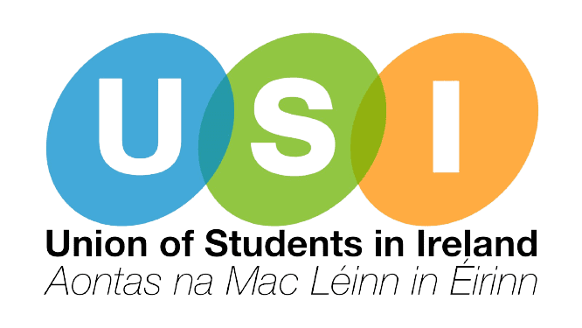

**Comhairle Náisiúnta AMLÉ**

*National Council of the Union of Students in Ireland*

**Meeting/Cruinniú:** National Council / Comhairle Náisiúnta

**Date & Time/Dáta & Am:** November 21st/21ú Samhain, 2.15pm

**Location/Áit:** Online / Ar Líne

[**ZOOM LINK**](https://us02web.zoom.us/j/86178190692?pwd=urk4bCKnc0M0FskW4MCrpoVQNe47yy.1)

**Attendees:** Bryan O’ Mahony USI/AMLÉ, Bláthín Nic a t-Sithigh AMLÉ, Emma Monahan USI/AMLÉ, Nathan Murphy USI/AMLÉ, Sarah Fitzpatrick USI/AMLÉ, Niamh Doherty USI/AMLÉ, Niamh Kennedy USI/AMLÉ, Ben Friel NUS-USI, Alishaeir Ahmed DCUSU, Jane Gartland IADTSU, Rhianna Foley McGuire STACSSU, Jordan Buckley NCISU, Stephen Fogarty MTUKSU, Shauna Ó Toole TUDSU, Katie Halpin-Hill UCCSU, Patrcyja Zbikowska MTUCSU, Amelia Lown TUSSU, Dara Lenihan TUSSU, Malcom McDonagh TUSSU, Chloe Anderson CMLOG, Tom Forde CMLOG

1. **Approval of external members (USI VP Academic Affairs)**
2. Miranda Bauer & Saskia McCormack Eiffe UCDSU were approved to attend Comhairle.
3. **Minutes / Miontuairiscí:**
4. [Minutes from the October Comhairle Náisiúnta](https://usiirl-my.sharepoint.com/:w:/r/personal/president_usi_ie/Documents/MO%20Resources%2024-25/Comhairle%20N%C3%A1isi%C3%BAnta/Online%20Comhairle%2021.11.2024/Supporting%20Materials/CN%2024_10_24.docx?d=w9d3a4b0d5a4c48e9bb9046a3a8435289&csf=1&web=1&e=cV0H9N) were approved.
5. **Elections / Toghcháin**
6. Vice President for Equality & Citizenship

i. Niamh Kennedy presented their candidacy and took questions.

ii. Niamh Kennedy was deemed elected as VP Equality & Citizenship.

1. The Chair informed Comhairle of a vacancy that has arisen on the Coiste Gnó for the position of Vice President for the Southern Region. The Elections Subcomittee will issue a formal notice to MOs on the 22nd November. Nominations for this position will close on the 30th November and an election will be held on the 12th December.
2. **Matters Arising / Nithe ag Éirí Astu:**
3. None
4. **Officer Reports / Tuairiscí Coiste Gnó**

[Tuairiscí Coiste Gnó - Samhain](https://usiirl-my.sharepoint.com/:f:/r/personal/president_usi_ie/Documents/MO%20Resources%2024-25/Comhairle%20N%C3%A1isi%C3%BAnta/Online%20Comhairle%2021.11.2024/Officer%20Reports?csf=1&web=1&e=u7UnSR)

1. The VP Academic Affairs offered to take questions on behalf of the President who was not present to present their report. There were no questions and the report was approved by Comhairle.
2. The VP Academic Affairs presented their report and took questions. The report was approved by Comhairle.
3. The VP Welfare presented their report. There were no questions and the report was approved by Comhairle.
4. The VP Campaigns presented their report. There were no questions and the report was approved by Comhairle.
5. The LÚ don Ghaeilge presented their report. There were no questions and the report was approved by Comhairle.
6. The VP Dublin Region presented their report. There were no questions and the report was approved by Comhairle.
7. The VP Southern Area presented their report. There were no questions and the report was approved by Comhairle.
8. The VP Academic Affairs offered to take questions on behalf of the VP BMW Region who was not present to present their report. There were no questions and the report was approved by Comhairle
9. The VP Postgraduate Affairs presented their report There were no questions and the report was approved by Comhairle.
10. **Items for Approval / Le Socrú**
11. [Revision of Constitutional Review Process](https://usiirl-my.sharepoint.com/:w:/r/personal/president_usi_ie/Documents/MO%20Resources%2024-25/Comhairle%20N%C3%A1isi%C3%BAnta/Online%20Comhairle%2021.11.2024/Supporting%20Materials/Proposed%20Motion%20Amendment.docx?d=w21527b5932484fc5af0a3669cf016e87&csf=1&web=1&e=JPOknn) (UCCSU) was carried.
12. Revision of Nomination for Chair of Constitutional Assembly (UCCSU; contingent on approval of item a.) was carried - nominations will be accepted for an election to be held on the 12th December.
13. **Items for Discussion / Le Plé**
14. Financial Update (USI President) was not available
15. **Items for Noting / Pointí Eoilais**
16. Media Report (USI President) was not available
17. **A.O.B / A.G.E.**
18. VP Campaigns raised the idea of a ‘vote left/transfer left’ pact for the upcoming general election and reiterated USI/AMLÉ’s positions of no confidence in the current government and not platforming the far-right.